Specifications about Motors

<https://www.bluerobotics.com/store/thrusters/t200-thruster/>

Software should focus on:

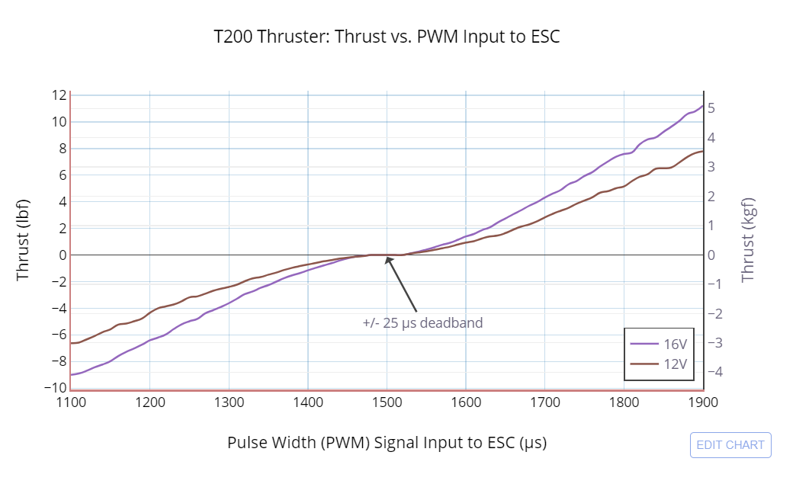

PWM values change direction and thrust power of motor. For function:

write_set_servos(servo_port, **pwm_value**)

~ 0 pwm: turns motors off

~1500 pwm: no thrust / Initialization for 5 seconds

< 1500 pwm: clockwise

> 1500 pwm: counter-clockwise

**Our motors are mounted correctly.**

**Forward Reverse**

1570 pwm and 1420 pwm: 0.5 Thrust

1610 pwm and 1380 pwm: 1.0 Thrust

1645 pwm and 1350 pwm: 1.5 Thrust

1665 pwm and 1320 pwm: 2.0 Thrust

1690 pwm and 1290 pwm: 2.5 Thrust

1710 pwm and 1275 pwm: 3.0 Thrust

Use values above 1500 for both motors when moving forward.

Use values below 1500 for both motors when moving backwards.

To turn left, right motor pwm > left motor pwm

To turn right, left motor pwm > right motor pwm

Higher the difference, faster it will turn

Port 9 is right thruster

Port 10 is left thruster

Port 7 is claw servo